MOST Ministries Teachers to the World - Scholarships
$ 5,000
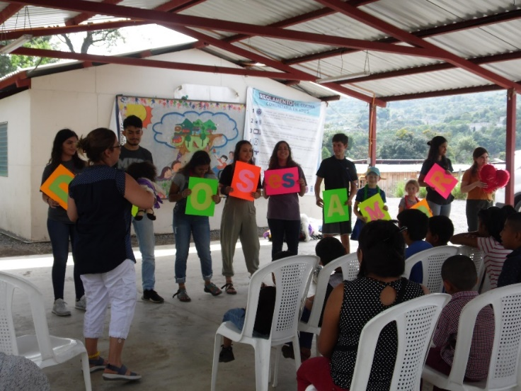
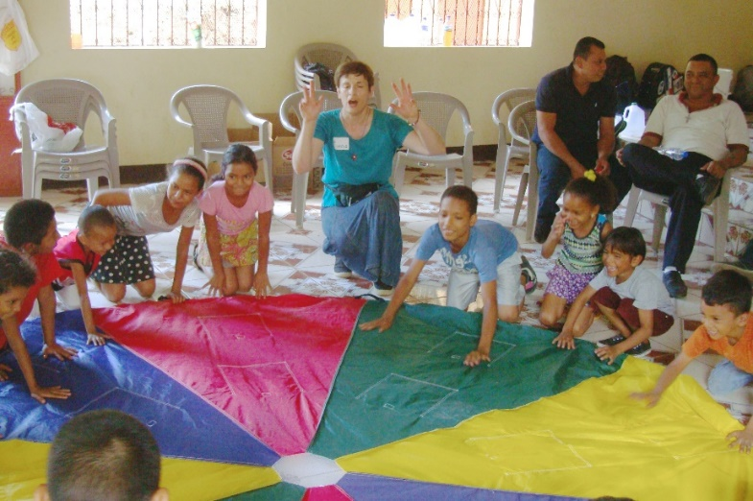

For over 30 years, MOST Ministries has assisted committed Christians from the U.S. to take mission trips around the globe to share the Gospel while meeting people’s physical needs. As we plan mission trips for 2022-2024, we would like to satisfy requests for children’s ministry projects. However, the willingness to join a MOST mission team is sometimes stymied by the reality of cost and cancelling a planned mission trip because of a dearth of team members is always tragic. MOST Ministries wishes to encourage the fulfillment of this Spirit-inspired yearning to go and teach children throughout the world by assisting aspiring team members to pay for the trip.

The funds provided by the LWML Washington-Alaska District grant will be used as scholarships for Lutheran teachers (Sunday School, pre-school, elementary, middle school, and high school), to cover up to half the cost (or $1,500) of their joining a children’s ministry team with MOST Ministries.

2022-2024 Biennium – LWML Washington-Alaska District

